a campaign page for the 2024 Met Gala
My role
Time line
skills
Team
Translated complex product requirements into structured user flows, collaborated with the PM to ensure logical transitions between screens, refined interaction flows, and gathered visual and typography references.
4 weeks March - May. 2024
launched in may 2024
prototyping
2 UX designers (including me) 1 Product managers Engineers team 1 visual designers
User research
Interaction design
Micro-interaction
impact
Designed a gamified campaign experience featuring a voting mechanism that drove engagement and participation, contributing to a record-breaking launch reaching 13.6M+ viewers and +71% content growth.
13.6M+
The #1
+71%
total viewers
Most-Watched Red Carpet Live
Engagement Growth
（Since April 29）
Context
As the lead sponsor of the 2024 Met Gala and The Costume Institute’s exhibition Sleeping Beauties: Reawakening Fashion, TikTok sought to extend the event experience beyond livestream viewing and into interactive platform engagement.🤩
The Challenge
Our team was tasked with translating complex product requirements into development-ready deliverables within just one month, with minimal official visual assets available.
⏳ tight Timeline
🧩 Multi-Phase Interaction Logic
✨ High Visual Bar with Limited Assets
Had only one month to convert complex requirements into finalized, developer-ready designs.
Designed a multi-phase experience integrating voting, rewards, rankings, and timed content transitions.
Established a fashion-level aesthetic with only a few official brand visual assets.
Highlights
01/
An Animated Entry That Draws Users In
Inspired by the Met Gala dress code The Garden of Time, we incorporated a rotating kaleidoscope visual motif. The experience opens with an entrance animation, uses motion to present rewards, and builds curiosity.
02/
Vote, Compete, Unlock
Users could first vote on past Met Gala looks , then vote on current looks once the event launches.
A competitive card interaction adds playfulness and implies that selecting one option discards the other.
03/
Designing for Continued Participation
After the initial 5 votes are used, users must complete tasks to earn more voting chances. The ranking of their favorite look is revealed only after all votes are cast.
04/
rewards & compete with your friends
See what rewards you’ve earned, compete with friends on the leaderboard, and discover others who share your taste—encouraging sharing and connection.
share my favorite look
iterations
1st iteration:
Translated PM requirements into a structured user flow, but uncovered hierarchy issues.
The reward section was too long and negatively affected the first screen efficiency .
The rewards themselves lacked strong appeal.
Simplified PM requirements into concise UX writing and a structured layout, streamlining the campaign’s interaction flow.
Drawing from previous Disney and Oscars campaign designs, i implemented a dark theme to evoke a evening-gala aesthetic.
The magazine-tearing concept fit past looks better but felt inconsistent with this year’s Met Gala visuals.
goal : improve the page hierarchy while keeping rewards engaging
Team insights
goal : make a complex flow clearer and more focused
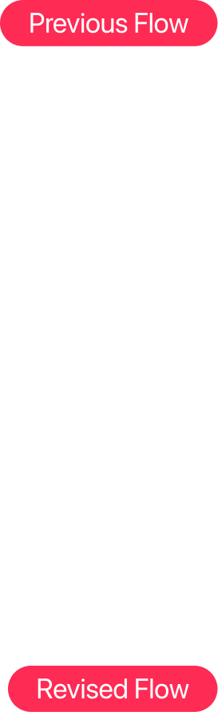2nd iteration:
Restructured Entry Interaction, Yet Still Lacking a Strong Fashion Identity
redesigned the reward section to appear at entry and automatically collapse afterward, and shifted the voting interaction to a card-based concept.
Simplified the visual language for greater clarity.
Used blur as a motivational cue to drive engagement.
lacked a strong fashion tone
goal : Establish a Strong Fashion Aesthetic
3rd iteration:
Added an Opening Animation, but Misaligned with This Year’s Theme
Repositioned Rewards to Prioritize Voting and Improve Flow Efficiency
The spotlight concept did not align with this year’s Met Gala theme
The reward section still disrupted the overall fashion tone of the page
final design
Snipets of the final design and interactions details that I feel proud of!
My biggest learnings
Collaborating in a fast-paced environment with designs that impact millions have taught me…
Iterate, fail, learn, repeat!
Design Under Pressure
There’s always room to improve. I’ve learned to move fast - iterate, learn, and repeat - while seeking experienced perspectives and asking for feedback strategically.
Working in high-expectation, high-pressure environments strengthened my resilience and discipline. The more intense the situation, the more essential it becomes to clarify the logic, move step by step according to plan.
Transparent Communication & Team Alignment
Not all requirements are equal.
Proactive and transparent communication keeps teams aligned and focused. Cross-functional collaboration often brings unexpected support and valuable insights that refine and elevate the final design.
In complex projects, the ability to prioritize what matters most determines the strength of the final outcome.

